

SMART EV CHARGING STATION QUEUE AND SLOT SCHEDULING SYSTEM
A Capstone Project Report submitted in partial fulfilment of the requirements for the
Course of

CSA0604-Design and Analysis of Algorithms

to the award of the degree of

BACHELOR OF ENGINEERING / BACHELOR OF TECHNOLOGY
IN AIML
Submitted by
G. Hari Prasad (192525273)

Under the Supervision of Dr M Manikandan

SIMATS ENGINEERING
Saveetha Institute of Medical and Technical Sciences Chennai-602105
SEPTEMBER 2026



BONAFIDE CERTIFICATE

This is to certify that the Capstone Project entitled “Smart Ev Charging Station Queue And Slot Scheduling System ” has been carried out G. Hari Prasd(192525273)under the supervision of Dr M Manikandan and is submitted in partial fulfilment of the requirements for the current semester of the B.Tech AIML Engineering program at Saveetha Institute of Medical and Technical Sciences, Chennai.

COURSE COORDINATOR COURSE FACULTY
Dr. F. Mary Harin Fernandez Dr M Manikandan
Professor, Professor
Department of CSE Department of CSE
SIMATS Engineering, SIMATS Engineering,
SIMATS,Chennai 602105 SIMATS,Chennai 602105



DECLARATION

We, K Baba Satya Kumar (192525226) of the Department of Artificial Intelligence and Machine Learning SIMATS Engineering, Saveetha Institute of Medical and Technical Sciences, Chennai, hereby declare that the Capstone Project Work entitled “Smart Ev Charging Station Queue And Slot Scheduling System” is the result of our own bonafide efforts. To the best of our knowledge, the work presented herein is original, accurate, and has been carried out in accordance with the principles of engineering ethics and academic integrity. All sources, references, data, and other materials used in the project have been appropriately acknowledged. We further declare that the data, results, analysis, and findings presented in this report have not been fabricated, falsified, or manipulated. Any external tools, software, datasets, computational resources, or AI-assisted tools used during the project have been appropriately disclosed. We confirm that all applicable ethical, academic, institutional, and professional requirements have been duly followed throughout the planning, execution, analysis, and documentation of the project.

Place:
Date:

Signature of the Student with Names
G. Hari Prasad (192525273)

Individual Contribution Statement

(Mandatory for all team projects)

Student Name / Register  No. | Specific  Responsibilities | Design & Development Contribution | Testing & Analysis  Contribution | Report  Contribution | Approx.  Contribution (%)
K Baba Satya Kumar  192525226 | Module 1 – User & Vehicle  Management; user, vehicle, validation and persistence  design | User/vehicle data model, interface flow,  validation and database integration | Planned  functional and  integration tests for  Module 1 | Ch. 1–5  sections related to  Module 1 | 25%
K. Anil Kumar  192525231 | Module 2 – Charging Station  Management | Charging-station information and  availability  management | Planned station and availability tests | Module 2 contribution | 25%
N. Deepak 192572075 | Module 3 – Queue & Slot Scheduling | Queue and slot  scheduling workflow | Planned  queue/slot tests | Module 3 contribution | 25%
G. Hari Prasad  192525273 | Module 4 – Dashboard & Reports | Dashboard and report  presentation | Planned  dashboard/report verification | Module 4 contribution | 25%
Total |  |  |  |  | 100%

ABSTRACT
Electric vehicle charging is increasingly treated as an infrastructure and service-management problem in which limited charging resources must be coordinated against competing user requests. The proposed Smart EV Charging Station Queue and Slot Scheduling System addresses the information-management layer of this problem through a web-based application architecture using Python, Flask, HTML5, CSS3, JavaScript where required, and SQLite/SQL. The overall design is divided into four interacting modules: User & Vehicle Management, Charging Station Management, Queue & Slot Scheduling, and Dashboard & Reports. This individual report concentrates on Module 1 – User & Vehicle Management, covering user registration, login and authentication concepts, profile management, input validation, vehicle registration, vehicle update/deletion, user–vehicle relationships, persistence, error handling, and integration with charging requests. At system level, the scheduling model follows a deterministic sequence: a charging request is associated with a validated user and vehicle, slot availability is checked, an available slot is allocated, and an unavailable request is entered into a queue whose order and status are maintained. The design deliberately separates application presentation, validation/business logic, and database access. Charging standards such as IEC 61851-1 and OCPP are reviewed as reference contexts; no physical charger control or protocol implementation is claimed in the present scope. Because this report documents the design and implementation plan before measured system execution, it does not claim execution times, accuracy values, database counts, user counts, station counts, or performance measurements. The intended engineering outcome is a structured academic prototype that demonstrates controlled identity and vehicle data management and provides a sound software foundation for coordinated charging-slot allocation and queue handling.

Keywords: Electric Vehicle Charging, Queue Management, Slot Scheduling, Flask, SQLite, User–Vehicle Management

TABLE OF CONTENTS
Sl.  No. | Title | Page No.
i | CERTIFICATE FROM THE SUPERVISOR | ii
ii | DECLARATION BY THE CANDIDATE | iii
iii | INDIVIDUAL CONTRIBUTION STATEMENT | iv
iv | ABSTRACT | v
v | LIST OF FIGURES | vi
vi | LIST OF TABLES | vii
vii | LIST OF ABBREVIATIONS / SYMBOLS | viii
1 | CHAPTER 1: Introduction and Engineering Problem | 1
2 | CHAPTER 2: Literature Review and Existing Solutions | 3
3 | CHAPTER 3: Engineering Design & Trade-offs, Sustainability, Ethics, Safety, Risk & Security | 4
4 | CHAPTER 4: Implementation, Testing & Results, Project Management | 8
5 | CHAPTER 5: Conclusion, Future Work and Reflection | 11
 | References | 12
 | Appendices | 13
 | Capstone Project Outcome Mapping Sheet | 14

LIST OF FIGURES
Figure No. | Figure Name | Page No.
Figure 1 | Overall System Architecture | 5
Figure 2 | Module 1 – User & Vehicle Management Architecture | 5
Figure 3 | Module 1 – User & Vehicle Management Flowchart | 6
Figure 4 | Conceptual Database / ER-style Model | 6
Figure 5 | Queue & Slot Scheduling Workflow | 6
Figure 6 | Complete System Workflow | 7
Figure 7 | Planned Development Timeline | 9
All figures are conceptual engineering designs for the proposed software prototype. They describe intended interfaces and data/control relationships rather than claiming completed runtime evidence.

LIST OF TABLES
Table No. | Table Name | Page No.
Table 1 | Engineering Problem Factors | 1
Table 2 | Literature / Existing Solution Comparison | 3
Table 3 | Functional and Non-Functional Requirements | 4
Table 4 | Constraints and Applicable Standards | 4
Table 5 | Design Specifications | 4
Table 6 | Alternative Solution Evaluation | 5
Table 7 | Sustainability, Ethics, Safety and Security | 7
Table 8 | Risk Register | 7
Table 9 | Development Tools and Resources | 8
Table 10 | Test Plan and Verification Matrix | 9
Table 11 | Objective Achievement Matrix | 9
Table 12 | Project Planning and Milestones | 10
Table 13 | Planned Budget Structure | 10
Table 14 | Module Responsibility and Integration Matrix | 10
Table 15 | Project Management Control Points | 10

LIST OF ABBREVIATIONS / SYMBOLS
Symbol | Description | Unit
EV | Electric Vehicle | —
EVSE | Electric Vehicle Supply Equipment | —
OCPP | Open Charge Point Protocol | —
CS | Charging Station Management System | —
UI | User Interface | —
DB | Database | —
SQL | Structured Query Language | —

API | Application Programming Interface | —
IEC | International Electrotechnical Commission | —
AC | Alternating Current | V
DC | Direct Current | V
ID | Identifier | —
Notation used in the report: “planned” describes intended functionality; “measured result” is reserved for values produced by executed tests. Standards and protocols are discussed as engineering context unless an implementation is explicitly
described.

CHAPTER 1 INTRODUCTION AND ENGINEERING PROBLEM

Background
Electric vehicle charging is increasingly viewed as a combined infrastructure and service-management challenge. A charging location can have a finite number of chargeable spaces or connector resources while demand may arrive in overlapping time windows. The software layer must therefore represent users, vehicles, charging resources and requests in a consistent way so that decisions about availability and waiting state are traceable. The International Energy Agency reported strong growth in public charging infrastructure in its Global EV Outlook 2025, reinforcing the practical relevance of organized charging-resource management.
The proposed project is a Smart EV Charging Station Queue and Slot Scheduling System. It is designed as a web-based academic prototype using Python, Flask, HTML5, CSS3, JavaScript where needed, and SQLite/SQL. The present scope focuses on the information and scheduling layer rather than direct physical control of charging equipment. The individual contribution is Module 1 – User & Vehicle Management, which establishes the identity and vehicle data required before a charging request can be processed.

Need for the Project
A station with limited charging resources must make allocation decisions when several users request service at the same time. Manual coordination can create ambiguity about which resource is available, whether a vehicle belongs to a registered user, and whether an unavailable request is waiting or rejected. A centralized application reduces these ambiguities by maintaining a single logical representation of users, vehicles, requests, slots and states.
Factor | Engineering implication | Relevance
Limited charging points | Simultaneous requests cannot all be served immediately. | Requires slot availability tracking.
Overlapping requests | Resource conflicts can occur when allocation is not centralized. | Requires request status and allocation rules.
User / vehicle data | A charging request must reference a valid user and vehicle. | Requires validation and database relationships.
Changing slot status | An allocated resource must not remain marked available. | Requires controlled status updates.
Waiting requests | Unavailable resources need a transparent waiting mechanism. | Requires queue insertion and status tracking.
Operational visibility | Users and operators need current request and resource information. | Supports dashboard and report functions.
Table 1. Engineering Problem Factors

Problem Statement
Design a structured software system that manages users, vehicles, charging stations, charging slots, and charging requests when available charging resources are limited and requests may overlap. The system shall preserve data integrity, validate inputs, associate vehicles with users, allocate an available slot where possible, place an unavailable request into a queue, and maintain status information that can be consumed by a dashboard or reporting layer.

Project Aim
The aim is to design and implement a web-based prototype for organized EV charging-resource management, with the individual contribution focused on reliable User & Vehicle Management and its integration with the charging-request workflow.

Project Objectives
- Design a user and vehicle information model suitable for charging-service requests.
- Develop user registration, authentication concepts, profile management and validation flows.
- Develop vehicle registration, update, deletion and information-management functions.
- Establish logical user–vehicle relationships and persistent storage using SQLite/SQL.
- Define a queue-based charging-request workflow for limited slots.
- Prepare functional and integration tests for user, vehicle, request, queue, allocation and status functions.

Scope
Included: user and vehicle records, validation, database persistence, charging-station and slot information model, request intake, queue logic, slot status representation, dashboard/report information model and planned functional testing. Excluded: physical charger control, payment processing, real-time charger telemetry, OCPP communication, cloud deployment, IoT integration and machine-learning optimization. Assumptions: the prototype uses a defined logical representation of charging slots and operates on application-level data. Boundary conditions: performance metrics and runtime evidence are not part of the design-only baseline.

Engineering Constraints
The principal constraints are limited software development resources, the need for consistent database state, variability in user input, the need for deterministic scheduling logic and the requirement that the application remain auditable. The design also has an evidence constraint: claims about actual execution, throughput, accuracy, user count, station count or cost are reserved for the implementation/testing stage.

Proposed Technical Approach
The application is planned around a Flask web layer, HTML5/CSS3/JavaScript interfaces and SQLite/SQL persistence. Presentation, validation/business logic and data access are treated as separate responsibilities. A charging request references a validated user and vehicle; slot availability is then evaluated. An available resource is allocated, while an unavailable request is inserted into the queue. Status transitions are persisted so that the dashboard/report layer can present the current state.

Expected Engineering Outcome
The intended outcome is a demonstrable academic prototype with traceable user and vehicle records, structured charging requests, explicit slot status, deterministic queue handling and a modular software architecture. Module 1 is expected to provide the clean identity/data foundation on which the remaining modules can operate.

CHAPTER 2 LITERATURE REVIEW AND EXISTING SOLUTIONS

Review Method
Relevant literature and technical resources were identified from recognized energy and standards organizations, official protocol documentation, and software documentation. The review emphasizes charging infrastructure growth, charging-management functions, queue/resource scheduling ideas, digital booking patterns and interoperability standards. The purpose is to define the engineering context and the scope boundary of the academic prototype rather than to claim protocol certification or industry-scale deployment.

Review of Existing Work
The literature indicates that EV charging management extends beyond the electrical connection itself. Public charging systems must represent physical resources, communicate status, manage user interaction and coordinate availability. In parallel, generic queueing systems provide a deterministic mechanism for handling demand when service capacity is temporarily constrained. Digital booking systems contribute reservation interfaces, record persistence and status tracking, while industry interoperability standards define communication behavior between charging equipment and management systems.
The proposed project combines these ideas at the software information layer. It does not attempt to reproduce the full feature set of a commercial charging platform. Instead, it provides a compact academic prototype in which a valid user and registered vehicle form the identity foundation for a charging request, while limited slots are handled by allocation or queue insertion.
Existing approach / technology | Advantages | Limitations for this project | Relevance
Manual / spreadsheet scheduling | Simple to start and requires little infrastructure. | Weak concurrency control, validation and status consistency. | Motivates centralized software workflow.
Commercial charging management platform | Handles real operational resources, user services and broader integration. | Beyond academic prototype scope and may include proprietary features. | Provides context for required resource/status concepts.
Web booking prototype | Accessible interface and  structured resource records. | May not represent real charger telemetry or electrical constraints. | Closest architectural basis for the proposed  prototype.
OCPP-based management | Supports standardized charger-to-system communication. | Protocol integration is outside the current implementation scope. | Reviewed as interoperability context only.
Proposed system | Combines user/vehicle records with slot allocation and queue status. | Prototype scope; no physical charger control. | Directly addresses the defined academic  information-management problem.
Table 2. Literature / Existing Solution Comparison

Comparative Analysis
The comparison supports a deliberate scope boundary. Commercial systems and protocol-based platforms solve broader operational and interoperability problems, whereas the proposed academic system concentrates on identity, resource representation and queue/slot status. This narrower focus supports explainable software design and makes the individual Module 1 contribution explicit.

Engineering Gap
A practical gap exists between simple digital booking and a charging-oriented resource-management prototype that explicitly connects validated user and vehicle information to charging requests and waiting-state management. The project does not claim to invent a new scheduling theory or charging protocol. Its engineering contribution is an integrated software model that links identity, vehicle association, resource availability and queue state in one auditable workflow.

Proposed Contribution
The individual contribution is the User & Vehicle Management module. Its role is to guarantee that downstream charging operations receive validated records. The dependency chain is: a valid user registers or selects a valid vehicle; the charging request references that vehicle; station and slot management evaluate the request; and the outcome is reflected in allocation or queue status.

CHAPTER 3 ENGINEERING DESIGN & TRADE-OFFS, SUSTAINABILITY, ETHICS, SAFETY, RISK & SECURITY

Requirements
The requirements are separated into functional and non-functional requirements. Each target is a design requirement to be validated during implementation; it is not a claim that the target has already been achieved.
Type | Requirement | Measurable target / verification method
Functional | Register user | Required fields stored; invalid or conflicting input rejected.
Functional | Authenticate user | Valid credentials accepted; invalid credentials rejected.
Functional | Manage profile | Permitted profile fields can be viewed and updated.
Functional | Register vehicle | Vehicle record linked to a valid user.
Functional | Update / delete vehicle | Authorized change persists and relationship rules are respected.
Functional | Validate inputs | Malformed, missing or inconsistent values produce controlled feedback.
Functional | Charging request integration | Request references a valid user and vehicle.
Functional | Queue unavailable request | Unavailable slot results in a queue state.
Functional | Allocate available slot | Available slot is assigned and status updated.
Non-functional | Data consistency | User, vehicle, request and slot states remain logically consistent.
Non-functional | Usability | Common operations reachable through clear forms/workflows.
Non-functional | Maintainability | Presentation, business logic and data access remain modular.
Table 3. Functional and Non-Functional Requirements

Constraints & Applicable Standards
Constraint / Standard | Requirement | How applied
IEC 61851-1:2017 | General requirements and safety context for conductive EV charging systems. | Used as reference context; physical EVSE control is excluded.
OCPP 2.0.1 / 2.1 | Open communication between charging stations and management systems. | Reviewed as interoperability context; not implemented or certified.
SQLite / SQL | Persistent relational storage for prototype records. | Planned as the application database layer.
Academic evidence discipline | Engineering claims should be supported by executed evidence. | Design-stage statements are separated from measured outcomes.
Table 4. Constraints and Applicable Standards

Design Specifications
Parameter | Target / Requirement | Unit | Priority
Application framework | Flask-based web application | — | High
Persistence | SQLite / SQL relational database | — | High
User identity | Unique user identifier and validated profile fields | record | High
Vehicle association | Each vehicle linked to a valid user | relationship | High

Slot state | Availability represented explicitly | state | High
Queue state | Unavailable requests stored with status/order | state | High
Input handling | Validation and controlled error feedback | — | High
Physical charger control | Excluded from current scope | — | Excluded
Table 5. Design Specifications
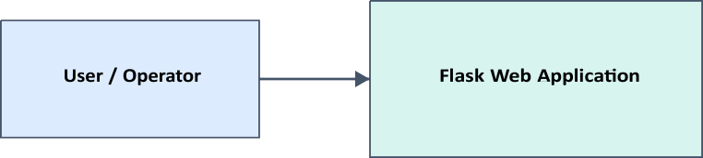

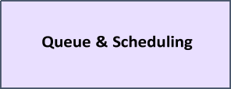

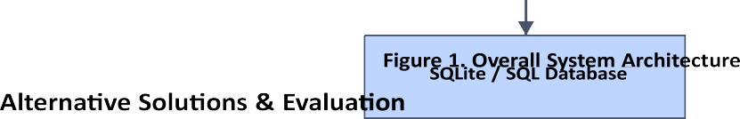
Alternative 1: Manual scheduling is easy to start but provides limited automation and weak state consistency. Alternative 2: Booking-only software improves record keeping but may not represent an explicit waiting queue. Alternative 3: The proposed modular Flask prototype combines identity, vehicle records, resource status, request handling and queue logic.
Criterion | Weight | Manual scheduling | Booking-only | Proposed modular prototype
Performance | 25% | Low | Medium | Medium–High
Data consistency | 20% | Low | Medium | High
Usability | 20% | Medium | High | High
Scalability | 15% | Low | Medium | Medium
Traceability | 10% | Low | Medium | High
Scope fit | 10% | Medium | High | High
Table 6. Alternative Solution Evaluation

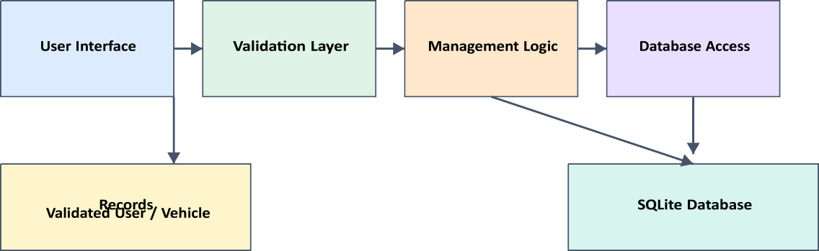

Figure 2. Module 1 – User & Vehicle Management Architecture

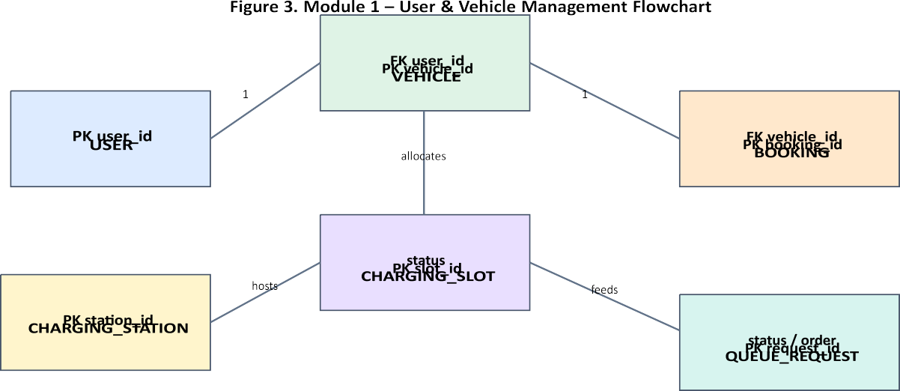
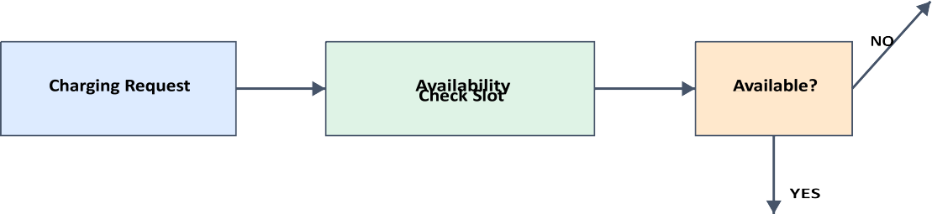
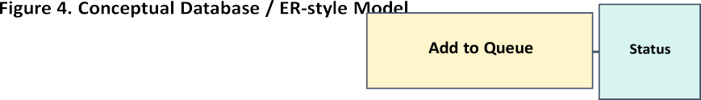
: many
: many

Allocate Slot |  | Status
Figure 5. Queue & Slot Scheduling Workflow
User
Ve | icle
Chargin | Request

Station / | lot Check
Slot Alloca | ion / Queue
Status | Update
Dashboar | d / Report
Figure 6. Complete System Workflow

Selected Design & Detailed Design
The proposed modular Flask architecture is selected because it offers a balanced combination of implementation simplicity, separation of responsibilities, local persistence and explicit control over state transitions. The decision follows the evaluation matrix: the design directly addresses the identified engineering factors without introducing unsupported protocol or hardware claims.

Trade-off Analysis
The central trade-off is between feature breadth and verifiability. Adding real charger telemetry, payments, mobile messaging or protocol integration would increase functionality but would also introduce additional interfaces, security boundaries and external dependencies. The current design deliberately keeps the application layer narrow so that Module 1 and the queue/slot workflow can be implemented, inspected and tested independently.

Sustainability, Ethics, Safety, Risk & Security
Domain | Consideration | Evidence evaluated | Impact on final decision
Sustainability | Prefer digital coordination over paper/manual records. | Electronic persistence and status tracking. | Supports a software-first architecture.
Ethics | Protect user identity and vehicle-related information. | Need-to-know data handling and validation. | Encourages controlled access and minimal data exposure.
Health & Safety | Avoid representing software as direct physical charger control. | Scope boundary and IEC context. | Keeps electrical safety outside unsupported software claims.
Security | Protect accounts and input paths. | Authentication concept, validation and database constraints. | Makes validation and authorization explicit design requirements.
Table 7. Sustainability, Ethics, Safety and Security
Risk | Likelihood | Severity | Risk level | Mitigation | Residual risk
Invalid user input | Medium | Medium | Medium | Server-side validation and controlled error handling. | Low–Medium
Duplicate / inconsistent vehicle data | Medium | Medium | Medium | Unique identifiers and user–vehicle relationship constraints. | Low
Incorrect slot state | Medium | High | High | Single status transition path and transaction-aware updates. | Medium
Unauthorized account access | Medium | High | High | Credential checks, session control and authorization rules. | Medium
Queue ordering defect | Low–Medium | Medium | Medium | Explicit queue order field and test cases. | Low–Medium
Table 8. Risk Register

Planned Module Integration View
The four modules are treated as interacting software subsystems. Module 1 supplies validated user and vehicle records. Module 2 maintains station and slot information. Module 3 consumes a valid request and determines allocation or queue state. Module 4 presents the resulting status for operational visibility.

Test Case | Input / Action | Expected Result | Actual Result | Status
TC-01 User registration | Submit valid registration details. | User record is stored and confirmation is shown. | Not measured at pre-implementation stage. | Planned
TC-02 Invalid user input | Submit missing/malformed required fields. | Validation message shown; invalid data not stored. | Not measured at pre-implementation stage. | Planned
TC-03 User update | Edit authorized profile fields. | Updated values persist. | Not measured at pre-implementation stage. | Planned
TC-04 Vehicle registration | Add vehicle for valid user. | Vehicle record linked to user. | Not measured at pre-implementation stage. | Planned
TC-05 Vehicle update | Edit valid vehicle record. | Updated values persist. | Not measured at pre-implementation stage. | Planned
TC-06 Invalid vehicle details | Submit malformed vehicle data. | Validation message shown; invalid data rejected. | Not measured at pre-implementation stage. | Planned
Test Case | Input / Action | Expected Result | Actual Result | Status
TC-07  User–vehicle relationship | Select vehicle for its owning user. | Valid reference accepted. | Not measured at pre-implementation stage. | Planned
TC-08  Charging request | Create request using valid user and vehicle. | Request enters allocation workflow. | Not measured at pre-implementation stage. | Planned
TC-09  Available slot | Submit request with free slot. | Slot is allocated and state updated. | Not measured at pre-implementation stage. | Planned
TC-10  Unavailable slot | Submit request when slot is occupied. | Request enters queue state. | Not measured at pre-implementation stage. | Planned
TC-11 Queue insertion | Inspect unavailable requests. | Queue order/status is retained. | Not measured at pre-implementation stage. | Planned
TC-12  Dashboard update | Process allocation/queue state change. | Dashboard reflects latest status. | Not measured at pre-implementation stage. | Planned

CHAPTER 4 IMPLEMENTATION, TESTING & RESULTS, PROJECT MANAGEMENT

Development Approach & Resources
The implementation is planned as an incremental web-application workflow. First, the data model for users and vehicles will be established in SQLite. Next, Flask routes and validation logic will be introduced, followed by interface forms for registration and profile/vehicle management. Finally, the module will be linked to the charging-request flow so that only valid user–vehicle combinations can enter allocation or queue processing. Testing will be carried out against functional requirements before the system is treated as an achieved implementation.
Tool / software / resource | Purpose | Stage used
Python | Application programming language and backend logic. | Implementation
Flask | Web routing, request handling and application structure. | Implementation
HTML5 | Page structure and form interfaces. | Implementation
CSS3 | Presentation and responsive layout. | Implementation
JavaScript | Client-side interaction where required. | Implementation
SQLite / SQL | Persistent relational storage. | Implementation
VS Code | Development, debugging and source management. | Implementation / testing
Table 9. Development Tools and Resources

Software Implementation
Module 1 is centered on the following logical operations: user registration, login/authentication concept, profile management, vehicle registration, vehicle update/delete, validation, database persistence, error handling and integration with charging requests.

Input validation is expected at both the interface and application layers so that database integrity does not depend solely on browser behavior.
Layer | Planned implementation responsibility
Presentation | Forms for user registration, login, profile and vehicle operations.
Validation / business logic | Field checks, authorization rules, relationship checks and controlled error handling.
Data access | Parameterized SQL operations for insert, update, delete and retrieval.
Integration | Validated user–vehicle reference supplied to charging request processing.
Status flow | Request linked to slot check, allocation or queue state.
Implementation evidence available at this report stage is limited to the proposed architecture and workflow. Runtime screenshots and measured outputs are intentionally not inserted as completed evidence.

Test Plan & Verification
Table 10. Test Plan and Verification Matrix

Results
At the pre-implementation stage, the report records design outputs, requirements and a planned test protocol rather than fabricated measurements. The key result of this phase is a complete software architecture and testable workflow: user → vehicle → charging request → station/slot check → allocation or queue → status update → dashboard. Quantitative performance, runtime screenshots and database counts will only become reportable after execution.

Data Analysis & Engineering Judgment
The principal engineering judgment at this stage is that explicit state representation is more important than adding unsupported automation. A request must have a known owner, a known vehicle and a deterministic outcome. In the proposed model, the state transition is visible and testable, which reduces ambiguity during later implementation. Performance analysis can subsequently be added using measurements such as response time, request throughput and queue waiting time.

Comparison with Existing Solutions & Achievement of Objectives
Objective | Evidence planned / produced | Achievement
User and vehicle information model | Conceptual data model and Module 1 architecture. | Design complete
Registration and validation workflows | Module 1 flowchart and test cases. | Design complete
Persistent storage | SQLite / SQL design and data-access layer plan. | Design complete
Queue-based request workflow | Queue workflow and integrated system flow. | Design complete
Testing and evaluation | Defined test plan and acceptance criteria. | Planned execution
Table 11. Objective Achievement Matrix

Strengths & Limitations
    - Strengths: modular structure, clear user–vehicle relationship, explicit state transitions, local relational persistence,testable workflows and a scope that is appropriate for an academic prototype.
    - Limitations: no direct charger control, no live telemetry, no payment integration, no cloud deployment, no OCPPimplementation and no measured performance at the design stage.

Project Planning, Roles & Budget
Planned Development Timeline

Sequence: define → design → build → integrate → test → demonstrate Actual dates and completion status are recorded during project execution.
Figure 7. Planned Development Timeline
Project coordination is organized as a sequence of requirements, data modelling, implementation, module integration, testing and final demonstration. Module responsibilities are distributed by the four project modules, while the individual report documents the contribution of K Baba Satya Kumar to Module 1.
Milestone | Main activity | Output
M1 | Requirements and problem definition | Scope, objectives and constraints
M2 | Database and Module 1 design | User/vehicle schema and validation logic
M3 | Flask implementation | Routes, forms and persistence
M4 | Module integration | Charging request and queue interface
M5 | Testing | Test execution records and defect log
M6 | Final report and demonstration | Validated report and prototype demonstration
Table 12. Project Planning and Milestones
Item | Estimated Cost | Actual Cost
Software tools listed in implementation plan | Local / existing academic resources | Not recorded at design stage
Development environment | Existing computer and software environment | Not recorded at design stage
Database | SQLite / SQL software stack | No separate software purchase planned
Deployment | Local prototype | Not recorded at design stage
Table 13. Planned Budget Structure
Module | Primary responsibility | Integration dependency
Module 1 – User & Vehicle Management | Identity, profile, vehicle records, validation and persistence. | Supplies validated user–vehicle data to charging requests.
Module 2 – Charging Station Management | Station information, connector/slot representation and availability state. | Provides resource state for scheduling.
Module 3 – Queue & Slot Scheduling | Allocation, waiting queue and status transitions. | Consumes request and resource state.
Module 4 – Dashboard & Reports | Status presentation and report-oriented views. | Displays allocation, queue and resource information.
Table 14. Module Responsibility and Integration Matrix
Management control point | Evidence to maintain | Decision / action
Scope control | Approved feature list and exclusions | Prevent unsupported features from entering the baseline.
Change control | Change description and reason | Review effect on requirements, interfaces and testing.
Test evidence | Test case ID, input, output and defect note | Accept only results supported by executed evidence.
Data integrity review | Schema, relationship and constraint checks | Correct ownership or state inconsistencies before integration.
Submission readiness | Report, source, screenshots and demonstration checklist | Confirm completeness before final academic submission.
Table 15. Project Management Control Points

CHAPTER 5 CONCLUSION, FUTURE WORK AND REFLECTION

Conclusion
The Smart EV Charging Station Queue and Slot Scheduling System is designed to address a practical software-management problem: limited charging resources may receive multiple overlapping service requests, creating a need for structured identity, availability and queue management. The proposed Flask and SQLite-based architecture separates user and vehicle information management from station, queue and dashboard responsibilities while connecting the modules through well-defined data relationships. The individual Module 1 contribution establishes validated users and vehicles as the information foundation for subsequent charging requests.
The report deliberately distinguishes engineering design from measured implementation. At this stage, the strongest validated outputs are the requirements, architecture, data relationships, workflow and test plan. Once the prototype is executed, the same structure can be extended with actual screenshots, database records, measured response times and test outcomes without changing the fundamental engineering model.

Future Work
Possible extensions include OCPP integration for standardized charger communication, real charger telemetry, mobile notifications, payment integration, cloud deployment, demand prediction, optimization, IoT integration and more advanced scheduling strategies. These are future engineering directions rather than current features of the academic prototype.

Professional Learning & Individual Reflection
New Knowledge Acquired: application-layer resource management, relational modelling for user–vehicle associations, validation design, deterministic queue workflows, and software-system decomposition.
Engineering & Professional Skills Developed: requirements analysis, modular architecture, data modelling, interface planning, test-case design, documentation and engineering judgment about scope and evidence.
Individual Reflection – K Baba Satya Kumar (Reg. No. 192525226), Module 1 – User & Vehicle Management The reflection in this pre-implementation report is intentionally written as a structured draft rather than as a claim about personal implementation experience. The most important engineering problem addressed in the assigned module is preserving a reliable
relationship between users and their vehicles so that later charging requests cannot reference incomplete or unrelated data. The key design decision is to place validation and persistence before charging-request processing, because downstream modules depend on trustworthy identity data. The independently developed knowledge areas are Flask request handling, relational persistence with SQLite/SQL, input validation and interface-to-database integration. When the implementation is complete, this paragraph should be replaced or expanded with the student’s actual debugging experience, evidence of a personal design decision, and a concrete redesign that would be made in a second iteration.

REFERENCES
- International Energy Agency, Global EV Outlook 2025: Electric Vehicle Charging, Paris: IEA, 2025.
- Open Charge Alliance, “OCPP: Discover our open standards for future-ready EV charging,” Open Charge Alliance, accessed Sep. 4, 2026.
- Open Charge Alliance, “New editions of the OCPP 2.1 and 2.0.1 now available!,” Dec. 4, 2025.
- Open Charge Alliance, “Download OCPP,” Open Charge Alliance, accessed Sep. 4, 2026.
- International Electrotechnical Commission, IEC 61851-1:2017, Electric vehicle conductive charging system – Part 1: General requirements,IEC, 2017.
- Open Charge Alliance, “Certification OCPP 2.0.1,” Open Charge Alliance, accessed Sep. 4, 2026.
- Python Software Foundation, Python Documentation, software documentation resource, accessed Sep. 4, 2026.
- Pallets, Flask Documentation, web framework documentation, accessed Sep. 4, 2026.

APPENDICES

Appendix A – Detailed Calculations
No lengthy numerical calculations are required for the present software design stage. The principal scheduling model is logical: request → availability check → allocation or queue insertion → status update. After implementation, measured waiting time, queue length, throughput or response-time calculations may be added from executed test data.

Appendix B – Engineering Drawings / Schematics
Figures 1–7 in Chapter 3 contain the primary architecture, flow, data and workflow diagrams. Additional implementation-level database schemas or interface wireframes may be attached after the final code structure is frozen.

Appendix C – Source Code / Code Repository Information
The complete application source is maintained separately from the report in the project workspace. This report intentionally contains the architecture and test plan rather than duplicating the full source code. The final approved repository location and commit reference can be inserted at submission time.

Appendix D – Datasheets
No physical charger hardware or component datasheets are claimed for the present software-only prototype scope.

Appendix E – Experimental / Raw Data
Raw test data will be appended after the implementation and test execution stage. The report design reserves this appendix for screenshots, output logs, test measurements and defect observations.

Appendix F – Ethics / Institutional Approval
The present work is a software engineering prototype. Any departmental or institutional approval required for later user studies, data collection or deployment will be documented here.

Appendix G – Project Meeting / Progress Records
Meeting minutes, milestone reviews and progress evidence can be appended here after project execution.

Appendix H – User / Industry Feedback
Feedback can be added after a review or demonstration session.
Appendix I – Publications / Patents / Competitions / Product Outcomes No such outcome is claimed in the present design-stage report.

Appendix J – Individual Contribution Evidence
The signed individual contribution statement and module-specific implementation evidence for K Baba Satya Kumar should be attached here at final submission.
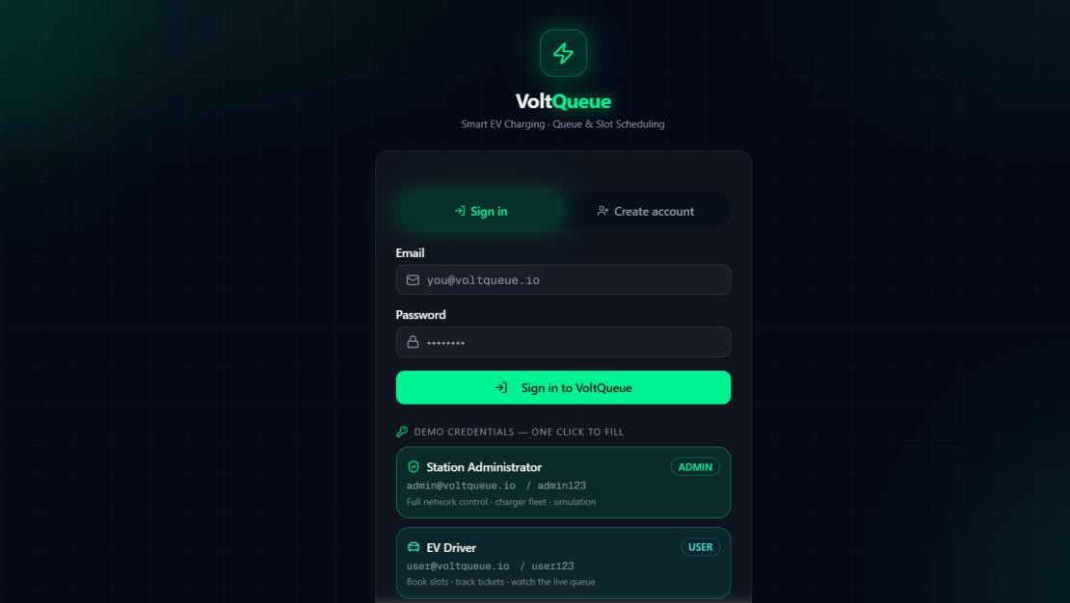

CAPSTONE PROJECT OUTCOME MAPPING SHEET
Outcome | Evidence | SO / Area | Location in This Report
Complex engineering problem formulation | Problem statement and engineering-factor analysis | SO1 | Ch. 1, Ch. 2
Engineering design under constraints | Requirements, standards, alternatives and trade-offs | SO2 | Ch. 3
Written/oral technical communication | Structured capstone report and figures | SO3 | Whole report + Viva
Ethics and professional responsibility | Sustainability, ethics, safety and security analysis | SO4 | Ch. 3 (3.7)
Teamwork and leadership | Module allocation and project planning | SO5 | Ch. 4 (4.8)
Experimentation, analysis, engineering judgment | Test plan, acceptance criteria and analysis framework | SO6 | Ch. 4 (4.3–4.6)
Independent acquisition of new knowledge | Reflection on software, database and workflow design | SO7 | Ch. 5 (5.3)
Standards | IEC 61851-1 and OCPP context | SO2 | Ch. 3 (3.2)
Sustainability and societal/environmental impact | Digital coordination and scope decisions | SO2/SO4 | Ch. 3 (3.7)
Risk assessment and mitigation | Risk register and mitigations | SO2/SO4 | Ch. 3 (3.7)
Security considerations | Authentication, validation and authorization concepts | Relevant SO | Ch. 3 (3.7)
Integrated/system-level engineering | Module interfaces and complete workflow | SO1/SO2 | Ch. 3 (3.5)
Project planning and management | Milestone plan, roles and budget structure | SO5 | Ch. 4 (4.8)
Individual contribution | Module 1 ownership and reflection | SO1–SO7 | Contribution Statement + Ch. 4 / Ch. 5

